Outdoor learning in Strandtown

December 2020
Dear parents and guardians,  We are beginning a very exciting journey within our Outdoor Learning this year at Strandtown! I am undertaking ‘Forest School’ training with the intention of developing our school as a Forest School. The Northern Ireland Forest School Association (NIFSA) based at Clandeboye in Bangor will be working closely with us and we intend to develop our abundant school grounds in the best possible way. Our intention is to engage the pupil voice and work together as a school to design areas around the school that can boost learning and improve our children’s mental health and wellbeing. Within the current climate, there is no better time for this! The benefits of engaging with the ‘Forest School’ ethos are endless and underpinned by the belief that ‘children are stimulated by the outdoors and typically experience, over time, an increase in their self-belief, confidence, learning, capacity, enthusiasm, communication and problem solving skills and emotional wellbeing.’ With advantages for both emotional health and curriculum delivery, it is an invaluable journey on which we embark. I plan to update you monthly with our activities and progress within school. | Where are we now?  Room 11 measure each other’s height using natural non-standard units!  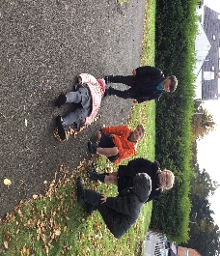  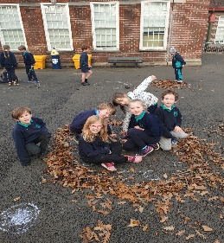  Room 7 make clocks using leaves and sticks!  Where are we going?  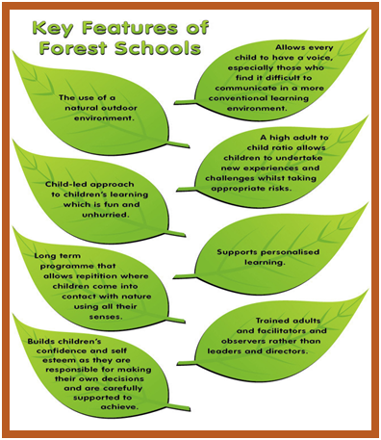  - Plans for planting are underway!  - Staff and pupil surveys to gather ideas to be carried out.  - Training to be undertaken  - Resources are being ordered.  Many thanks,  R McCoy

