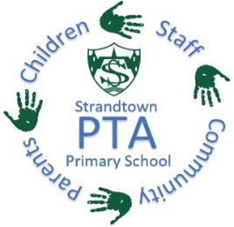
STRANDTOWN PRIMARY SCHOOL PTA

Easter Egg Hunt

It’s time again for our Easter Egg Hunt, we have an Easter egg for every class (“free from” eggs also available). For a chance to win their class egg your child can buy a square, or many squares, on the Easter picture in their classroom, 50p per square. The egg is hidden in one of the squares.

Squares will be on sale from Tuesday 2nd April. The square containing the egg will be revealed to each class on Thursday 11th April and the winning pupils announced. The Easter Bunny is on his way!

Thank you for your continued support & Happy Easter!
Strandtown PTA

Northern Ireland Charity number: NIC104244

STRANDTOWN PRIMARY SCHOOL PTA

Easter Egg Hunt

It’s time again for our Easter Egg Hunt, we have an Easter egg for every class (“free from” eggs also available). For a chance to win their class egg your child can buy a square, or many squares, on the Easter picture in their classroom, 50p per square. The egg is hidden in one of the squares.

Squares will be on sale from Tuesday 2nd April. The square containing the egg will be revealed to each class on Thursday 11th April and the winning pupils announced. The Easter Bunny is on his way!

Thank you for your continued support & Happy Easter!
Strandtown PTA

Northern Ireland Charity number: NIC104244

