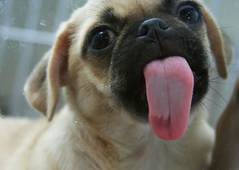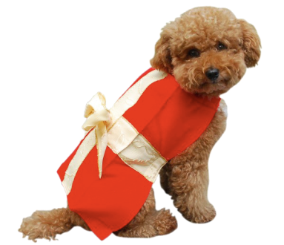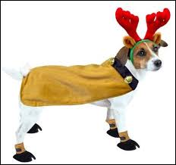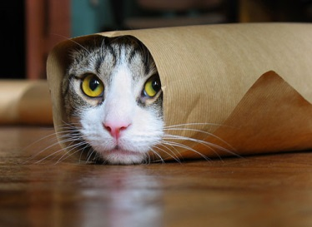

Send in a picture of your crazy pet.

£1 per entry

Little Wing Family Voucher for the craziest funniest pet picture entered.

You can enter your Grandparents, Auntie, Uncles or Family Friends pet as long as you have permission.

Pictures to be handed into Room 20 no later than

Friday 9th February 2018

Remember to put your name and room number on the back of your photo.

Do you have a cute, crazy or very cool pet?

PTA Presents….

Winter Pet Photo Competition