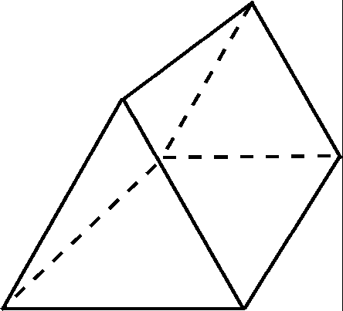

Triangular prism

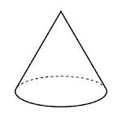

Cone

Cylinder

Sphere

Cuboid

Cube

There are many other common 3D shapes, including:

Equilateral

triangle

Right angled triangle

Any shape with 3 sides and corners is a **triangle**.

A **2D SHAPE** is a **flat** shape with only **one face.**

**Angles** are found in the corners of shapes.

**Right Angles** make an L shape in the corner and measure 90°.

A shape has a **line of symmetry** if it can be folded in half perfectly.

A **square** has **4 lines of symmetry** and a **rectangle** has **2 lines of symmetry**.

* I can name and describe the properties of common 3D shapes



**Steps 2 3D Shape Success**

A shape can have **parallel lines.** These lines never meet or get further apart, a bit like train tracks!

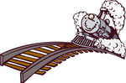

**IMPORTANT LANGUAGE!**

**Regular** shapes have equal sides and angles.

**Irregular** shapes have unequal sides and angles.

A **quadrilateral** is any shape with 4 sides and corners.